**POTTER COUNTY COMMISSIONER'S COURT ADDENDUM TO AGENDA**

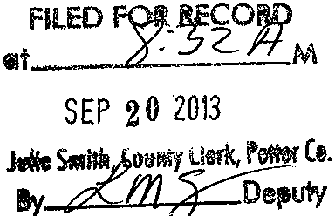

**September** 23, **2013**

THE FOLLOWING MATTERS WlLL COME BEFORE THE POTTER COUNTY COMMISSIONERS' COURT ON MONDAY, SEPTEMBER 23, 2013, AT 9:00A.M. IN THE POTTER COUNTY COMMISSIONERS' COURTROOM LOCATED AT 500 S. FILLMORE

STREET, ROOM 106, AMARILLO, POTTER COUTY, TEXAS.

1. To consider and act upon setting a bond for the Elections Administrator and her deputies

in accordance with Texas Elections Code§ 31.040 [Ware, Smith].

THIS AGENDA NOTICE IS MADE IN ACCORDANCE WITH CHAPTER 551, TEXAS GOVERNMENT CODE, PROHIBITION OF GOVERNMENTAL BODIES FROM HOLDING MEETINGS WHICH ARE CLOSED TO THE PUBLIC, AS AMENDED. THE DOCUMENTATION FOR THIS AGENDA NOTICE IS AVAILABLE FOR THE PUBLIC'S INSPECTION IN EITHER OF THE FOLLOWING OFFICES: THE COUNTY JUDGE, THE COUNTY CLERK, THE COUNTY AUDITOR OR THE COUNTY PURCHASING AGENT'S OFFICE.

\

I



ARTHUR WARE

POTTER COUNTY JUDGE